Cover slide:
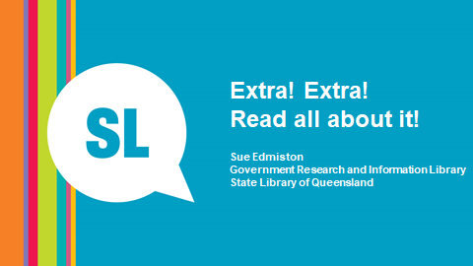

Slide 2: Photos
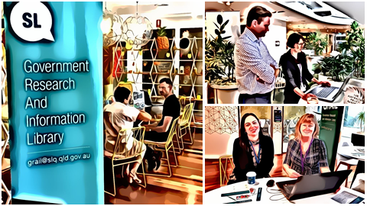
This is the story of the GRAIL transition from Publisher to Newsdesk – both LexisNexis media alerting tools.
Firstly, who is GRAIL? It’s the Government Research and Information Library at the State Library of Queensland
– so it’s a special library within a library.

The staff are highly trained specialist librarians with extensive experience working with clients from Queensland State Government Departments.

Our members include public servants from some of the key departments, including Department of the Premier and Cabinet, Queensland Treasury, Trade and Investment Queensland, and others.
In line with their very diverse needs, GRAIL does research on a really broad range of topics – smart cities, regional development, economic policy, autonomous vehicles, trade - you get the picture
Slide 3: GRAIL Newsletter site
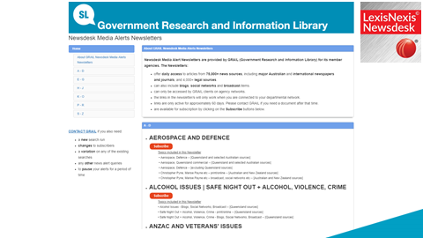
What you see on the slide is the current page for members to subscribe to a media alert.
Everything from Aerospace to Urban Planning.
How did we get here?
One of the biggest needs of all our clients, is keeping up with current and breaking news - being aware of new developments, or the general state of play, in their area of interest.
Media alerting was something GRAIL has offered for many years, using a number of different platforms, including Factiva and moving to Nexis Publisher in 2011.
It was always a popular and highly valued service.
When Nexis came to us and said they were phasing out Publisher and introducing a new product with more features, we were open to the idea.
The new features included TV and Radio broadcast and transcripts, and social media coverage – features that we knew our clients were keen to have.
GRAIL has always seen the importance of being at the leading edge for technological delivery of our services – and the need to keep pace with changing client needs. So the decision to go early – be early adopters of this new product – seemed to be the logical way to go.
There was also, of course, the added advantage of being able to negotiate a good price.
But one, somewhat unexpected, benefit was the opportunity to be heavily involved, and influential, in the development of Nexis Newsdesk.
We were able to take this new, still under development, product and to make it into our own.
All good so far BUT there was no question that the transition had to happen with no interruption to the media alerting service – easier said than done.
But never afraid of a challenge, we took a deep breath and dived in.

Slide 4: Search string
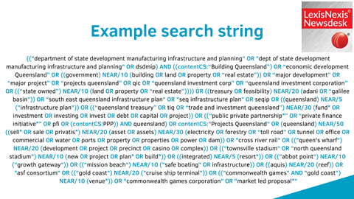
Originally we were given 59 days to transition, with both Publisher and Newsdesk running simultaneously - but once we began we realised that this was going to be a much bigger task than either GRAIL or Newsdesk realised.
In fact it ended up taking four months, and during that time we had two part time staff offline – no small thing in a very busy library!
However, we were ably supported by the rest of the very accommodating GRAIL team who picked up all our usual work and offered words of encouragement. This was very much a team effort, including the negotiation of the further 2 months transition time.

What did we do with all that time?

We spent a lot of time constructing and testing new searches. The two platforms were quite different, and all the search syntax was completely different, so a simple copy and paste of search strings was not possible. Many hours were spent identifying problems and finding solutions.
Along the way we had regular meetings with the Newsdesk development team, both here and in the US, where we discussed problems and solutions together.
We also consulted with selected clients to ensure the “new” searches were delivering what they needed. They and we took the opportunity to update the searches, some of which had been running for years.

Keeping our clients informed was really important and helped us to achieve a relatively smooth transition.
What you see on the screen is the end result of but one of the approximately 300 searches we constructed. Some of the more complicated searches took hours to put together but if you get this part right you get great results. Get it wrong and you end up with rubbish results and cranky clients.
Slide 5: Broadcast page
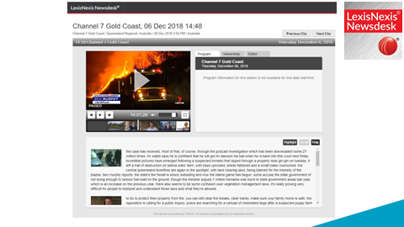
Getting the search right is important but getting the sources right was vital.
So Newsdesk might boast over 75,000 sources BUT as this was a US company our local and regional sources were mostly not included.

Added to that was the problem of misidentification – some of our Gold Coast publications were included, but were tagged as being from the US, or sometimes Africa!

It seems that geography is not one of their strengths in the US. Now where exactly is Queensland????

We identified local TV, and Radio sources (like this one – Channel 7 Gold Coast), and social media sources, and sent them to the US team to be added.
Having done that, we created source lists which could be used across multiple searches.
Broadcast is very popular but comes with its own set of challenges. A big selling point is Newsdesk provides free access to TV and Radio clips and transcripts, which is something our GRAIL members hadn’t had before.

Having said that, machine generated transcripts are not always accurate.
We came across reports of a Tight pants snake – a new species perhaps? Or was it really a Taipan?
And who knew that white spot disease was causing problems for the porn farming industry in Queensland – or even that Queensland HAD a porn farming industry!

Interestingly, social media has not been as popular as we expected, perhaps because it is restricted to public sites such as Facebook pages for politicians or organisations.

Slide 6: Newsletter
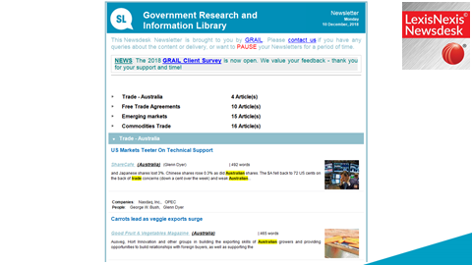
All of that behind the scenes work, meetings with clients, meetings with the Australian and US development teams, hours of sweating over syntax and sources, has brought us to this.

Branding and customisation were very time consuming, involving huge amounts of testing and refining, and backwards and forwards to the US development team.
The end result is this highly functional, branded newsletter that is automatically delivered, usually daily, by email.

Slide 7: Quotes
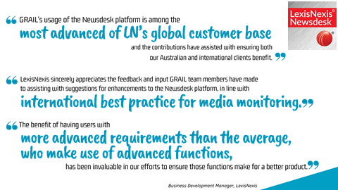
Two years later – was it worth it?
DEFINITELY!
We have gone from about 77 alerts being delivered to about 170 recipients
to over 300 searches, compiled into 75 newsletters and going to more than 500 recipients – and this includes some going to work group emails, so it could be many more.

Our clients love the fact that they can contact us directly if they need a personalised search or if a search needs tweaking.
And the availability of broadcast material has been very well received.
If there is a breaking news event like a cyclone, or the Queensland bushfires, updates can be delivered every 15 minutes if that’s what they want.

And we love the great relationship we’ve built with the Newsdesk team as we’ve co-developed this product.
None of us realised just how big a task this was going to be – but we got there.
--------------------
This is truly a story of a library and an industry partner working together to deliver the best outcomes for our clients.
We didn’t give up – we kept going back with problems and suggestions, and Newsdesk kept working with us to come up with solutions.
We have developed a relationship of mutual respect, and find our feedback is sought when new developments are in the pipeline. When issues arise, we are listened to, and the issues acted upon.
What more can you ask? It’s a great outcome. And the biggest winners from all this? Our clients. And that’s as it should be.

