5 Ways to be an Empathetic and Resilient Client Service Librarian
Or 5 tips for being a client service librarian who treats everyone including diverse communities with empathy and compassion and therefor succeeds as a person

Good Morning
I am Leela and I am the weekend and evenings coordinator at the State Library of Queensland and a reference librarian - this just means I’m a normal reference librarian who also looks after the library when there is no-one more senior around.

For people who know me or have seen me speak before this might come as a surprise but public speaking makes me really nervous. Rationally I’m fine, I’m prepared, I’ve practiced, I know my stuff - its only 8 minutes right? I even like it! And yet … my hands are shaking, my face is red and I’ve been worried for weeks about how I’ll talk maniacally, uming every second.

All the stuff that I just described that I feel 5, I feel when I am walking into a situation with a client where I have to stand up for my libraries policies or where there might be some sort of conflict. Rationally I know I’ve got this - I know my policies and guidelines back-to-front. I have solid moral compass. I have the ability to be empathetic. but rationality is not helping - I’m still nervous.

Now I’ve been working in customer service since I was 14. I have pretty extensive management and supervisory experience. I can problem solve, allay concerns, think on my feet and be charming, it takes a lot out of me but I’m good at it.

But customer service anywhere where there is an economic element in the transaction is different to public service in a library. We have to be accountable to the individual whilst also being accountable to the people sharing the space whilst also being accountable to the wider community. We run an essential service - we cannot afford to alienate, condemn or belittle demanding or difficult or unpleasant people - they all have a right to our services.

So - as a conflict averse introvert I am here to take you through my 5 ways for being an empathetic and resilient client service librarian because I believe this is something you can learn and not something you were born with.

And now we arrive at my first ‘tip’ - Check your purpose:

Ryan Dowd, who runs training sessions for librarians on how to better help homeless people, advocates understanding and keeping front of mind your purpose to help stave of frustration and burnout.

He suggests:
1. You clarify for yourself (and your staff) why your work matters.
2. You accept that your bad days are your gift to a hurting world.

There is contention about the role of libraries and librarians in society. I have been seeing a ‘libraries as social superpower’ feeling in the media zeitgeist and I believe that can be problematic but an undeniable truth is that whether you work with clients or not - without community we are purposeless.

Our role as information mediator is many and varied but the anecdotal evidence overwhelmingly suggests that those in front line service positions are answering questions whose responses will often inform the path in a person’s hardest and most vulnerable times. As such keeping in mind a purpose will help you remain empathetic resilient.

The next tip!

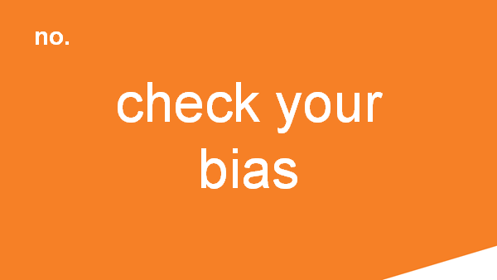

Alright everyone - for this next tip there is a little audience participation. You ready?
So drop what your doing, go and complete a bachelor of arts focusing on sociology and politics particularly feminitst theory and neo-colonial theory. I want you to read heaps of Weber, Foucault and Dirkheim. I want you to have a really good look at class, intersectionality, economic theory and intergenerational poverty and then meet me back here.

Good? Great off you go then, I’ll wait…

Obviously I jest but here's the thing - There was a study done that used students' final assessment to measure the effectiveness of teaching social theory alongside community service and it worked. Students were more aware of the factors outside a persons control that resulted in their situation.

Understanding the structural inequalities and the way power affects the everyday lives of marginalised peoples make it harder to rely on your biases. When you rely on off the shelf stereotypes to form opinions or make decisions regarding your service then you are doing damage. However, if you treat each person with empathy and be considerate of their position in society but not blame the person for the things about them that make you uncomfortable you will be able to give that person the service that they need.

Now I know it sounds like I am saying that only a person with an educational background like the one I describe above can challenge their biases but I am not, I promise. There are other ways to challenge your biases - the Harvard implicit test is one good example among many. Simply interacting with stories by creators from different ethnic or class backgrounds can help.

… but seriously also go and study sociology.

This brings me to my next tip ...
Beyond checking your bias you have to actively go into situations without the baggage of past experience. This is where your intention matters.
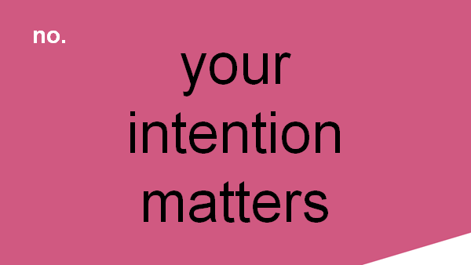

In my capacity as duty officer I am called to mediate issues reasonably often. As any library does we have regular clients who can on occasion cause trouble - or just be involved in troubling situations - and often the incidents I am called to involve them. It got to a point where in an effort to be prepared for the incident I was being called too, I would work myself into a lather of fear and anxiety trying to plan and predict the problem. I realised this state I was working myself into looked to the client like fear and agitation about them and judgement about the situation.

This is why your intention matters. If you go into a situation with the intention to listen and come to a resolution you have a better chance of reaching that resolution. Further if you keep calm, be fair and listen without bias the other patrons will witness that and be more accepting of diversity in the library. If the librarian isn’t calm and welcoming neither are the patrons.

Alright! Next tip -

Let me begin with a quote -

‘If compassionate listening constitutes a path to (ethical).... relations perhaps we need to see it as a moral imperative and begin thinking of ways to implement it in our teaching, in our collegial relationships and in our daily lives. We might then view listening as a form of social action, as a type of social transformation’ Frida Kerner Furman

Did you hear that? ‘Listening as a form of social action’. Listening! A simple boring skill that your primary school teachers always said you needed to improve on. Done well, it's a powerful social action. Forget protesting go and learn to listen to people - especially those that are different to you.

Listening to their concerns can precipitate a change in people and the essence of good listening is empathy, setting aside ones own ego and presumptions - including any presumptions of ‘but this isn’t part of my job’.

Which brings me to my final and briefest tip - this is probably where I get most self-righteous - I know, right - hard to believe.

Our product is good (read: great) but getting there has to be a good experience - you are not inherently good at mediating the experience. Service is a learned skill - give it the honor of a learned skill.

There is nothing wrong with not liking client service and not everyone is cut out for it.
But If you’ve signed up to be a reference librarian and some of your job is client service and you’re all like ‘well that's just the painful necessity of doing research’ then just don't - get another job. Client interaction is just too important to the story we are telling the community, the voices we are privileging, the people we care for and our role in society to have people out there who don't care.

If you do care but think you’re not good at people - I am living proof that being good at people is a learnt skill - being empathetic, dealing with conflict, listening, are learned skills - it might take a lot but give it a go, take care of yourself and leave if you stop caring about the people you serve.

That was my 5 ways to be an empathic and resilient client service librarian.

